**Министерство цифрового развития, связи и массовых коммуникаций Российской Федерации**

**Ордена Трудового Красного Знамени федеральное государственное бюджетное образовательное учреждение высшего образования**

**«Московский технический университет связи и информатики»**

**Факультет «Сети и системы связи»**

**Лабораторная работа по теме**

**«Расписание»**

Выполнила студентка

Группы БИН2002

Тарыгина Е. М.

Проверил:

Чайка А. Д.

Москва

2021

**Содержание отчета**

Цель работы 3

Выполнение работы 3

Результат выполнения 16

Вывод 16

**Цель работы**

Создание оконного приложения с использованием PyQt5.QtWidgets

и PostgreSQL с расписанием для своей группы.

**Выполнение работы**

Создадим проект нашего бота, для чего начнем с базы данных, которая изображена на рисунках 1-2.

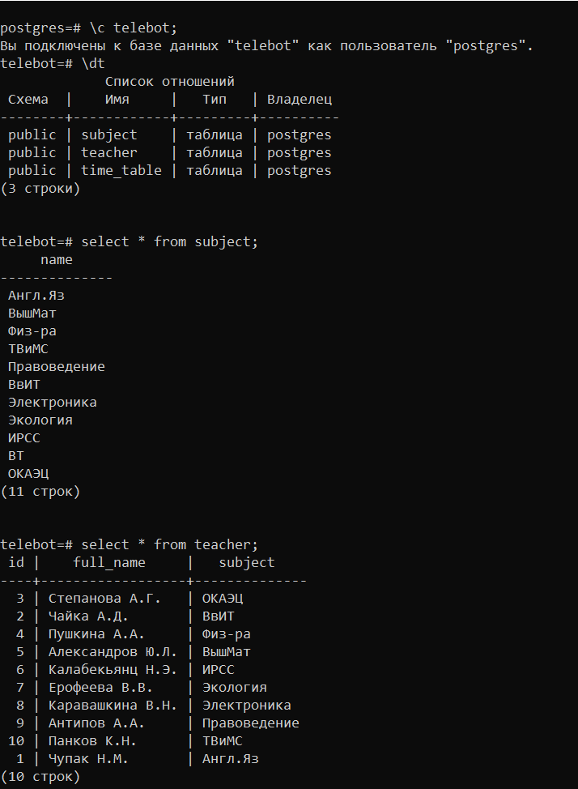

Рисунок 1 – База данных

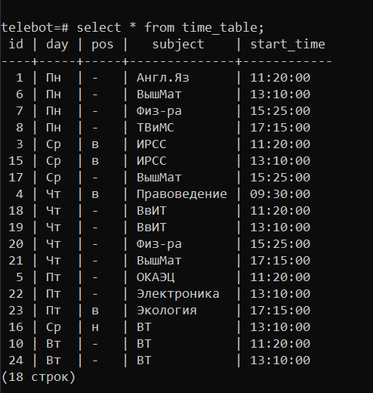

Рисунок 2 – База данных

Программный код изображен на рисунке 3.

import sys  
import psycopg2  
from PyQt5.QtWidgets import (QApplication, QWidget, QTabWidget, QAbstractScrollArea, QVBoxLayout, QHBoxLayout,  
 QTableWidget, QGroupBox, QTableWidget, QGroupBox, QTableWidgetItem, QPushButton,  
 QMessageBox)  
  
  
class Window(QWidget):  
 def __init__(self):  
 super(Window, self).__init__()  
 self.setWindowTitle("Расписание")  
  
 self._connect_to_db()  
  
 self.tabs = QTabWidget(self)  
  
 self.vbox = QVBoxLayout(self)  
 self.vbox.addWidget(self.tabs)  
 self._create_shedule_tab()  
  
 def _connect_to_db(self):  
 self.conn = psycopg2.connect(database="telebot",  
 user="postgres",  
 password="1234",  
 host="localhost",  
 port="5432")  
 self.cursor = self.conn.cursor()  
  
 def _create_shedule_tab(self):  
 self.shedule_tab = QWidget()  
 self.tabs.addTab(self.shedule_tab, "Расписание")  
 self.teacher_tab = QWidget()  
 self.tabs.addTab(self.teacher_tab, "Преподаватели")  
 self.subject_tab = QWidget()  
 self.tabs.addTab(self.subject_tab, "Предметы")  
  
 self.monday_gbox = QGroupBox("Понедельник")  
 self.tuesday_gbox = QGroupBox("Вторник")  
 self.wednesday_gbox = QGroupBox("Среда")  
 self.thursday_gbox = QGroupBox("Четверг")  
 self.friday_gbox = QGroupBox("Пятница")  
 self.teacher_gbox = QGroupBox("Перподаватели")  
 self.subject_gbox = QGroupBox("Предметы")  
  
 self.svbox = QVBoxLayout()  
 self.shbox1 = QVBoxLayout()  
 self.shbox2 = QHBoxLayout()  
 self.svbox2 = QVBoxLayout()  
 self.shbox21 = QVBoxLayout()  
 self.shbox22 = QHBoxLayout()  
 self.svbox3 = QVBoxLayout()  
 self.shbox31 = QVBoxLayout()  
 self.shbox32 = QHBoxLayout()  
  
 self.svbox.addLayout(self.shbox1)  
 self.svbox.addLayout(self.shbox2)  
 self.svbox2.addLayout(self.shbox21)  
 self.svbox2.addLayout(self.shbox22)  
 self.svbox3.addLayout(self.shbox31)  
 self.svbox3.addLayout(self.shbox32)  
  
 self.shbox1.addWidget(self.monday_gbox)  
 self.shbox1.addWidget(self.tuesday_gbox)  
 self.shbox1.addWidget(self.wednesday_gbox)  
 self.shbox1.addWidget(self.thursday_gbox)  
 self.shbox1.addWidget(self.friday_gbox)  
 self.shbox21.addWidget(self.teacher_gbox)  
 self.shbox31.addWidget(self.subject_gbox)  
  
 self._create_monday_table()  
 self._create_tuesday_table()  
 self._create_wednesday_table()  
 self._create_thursday_table()  
 self._create_friday_table()  
 self._create_teacher_table()  
 self._create_subject_table()  
  
 self.update_shedule_btn = QPushButton("Update")  
 self.update_teacher_btn = QPushButton("Update")  
 self.update_subject_btn = QPushButton("Update")  
 self.shbox2.addWidget(self.update_shedule_btn)  
 self.shbox22.addWidget(self.update_teacher_btn)  
 self.shbox32.addWidget(self.update_subject_btn)  
 self.update_shedule_btn.clicked.connect(self._update_shedule)  
 self.update_teacher_btn.clicked.connect(self._update_teacher)  
 self.update_subject_btn.clicked.connect(self._update_subject)  
  
 self.shedule_tab.setLayout(self.svbox)  
 self.teacher_tab.setLayout(self.svbox2)  
 self.subject_tab.setLayout(self.svbox3)  
  
 def _create_monday_table(self):  
 self.monday_table = QTableWidget()  
  
 self.monday_table.setSizeAdjustPolicy(QAbstractScrollArea.AdjustToContents)  
  
 self.monday_table.setColumnCount(6)  
 self.monday_table.setHorizontalHeaderLabels(["Позиция", "Предмет", "Время", "ID", "", ""])  
 self.monday_table.hideColumn(3)  
  
 self._update_monday_table()  
  
 self.mvbox = QVBoxLayout()  
 self.mvbox.addWidget(self.monday_table)  
 self.monday_gbox.setLayout(self.mvbox)  
  
 def _create_tuesday_table(self):  
 self.tuesday_table = QTableWidget()  
  
 self.tuesday_table.setSizeAdjustPolicy(QAbstractScrollArea.AdjustToContents)  
  
 self.tuesday_table.setColumnCount(6)  
 self.tuesday_table.setHorizontalHeaderLabels(["Позиция", "Предмет", "Время", "ID", "", ""])  
 self.tuesday_table.hideColumn(3)  
  
 self._update_tuesday_table()  
  
 self.mvbox = QVBoxLayout()  
 self.mvbox.addWidget(self.tuesday_table)  
 self.tuesday_gbox.setLayout(self.mvbox)  
  
 def _create_wednesday_table(self):  
 self.wednesday_table = QTableWidget()  
  
 self.wednesday_table.setSizeAdjustPolicy(QAbstractScrollArea.AdjustToContents)  
  
 self.wednesday_table.setColumnCount(6)  
 self.wednesday_table.setHorizontalHeaderLabels(["Позиция", "Предмет", "Время", "ID", "", ""])  
 self.wednesday_table.hideColumn(3)  
  
 self._update_wednesday_table()  
  
 self.mvbox = QVBoxLayout()  
 self.mvbox.addWidget(self.wednesday_table)  
 self.wednesday_gbox.setLayout(self.mvbox)  
  
 def _create_thursday_table(self):  
 self.thursday_table = QTableWidget()  
  
 self.thursday_table.setSizeAdjustPolicy(QAbstractScrollArea.AdjustToContents)  
  
 self.thursday_table.setColumnCount(6)  
 self.thursday_table.setHorizontalHeaderLabels(["Позиция", "Предмет", "Время", "ID", "", ""])  
 self.thursday_table.hideColumn(3)  
  
 self._update_thursday_table()  
  
 self.mvbox = QVBoxLayout()  
 self.mvbox.addWidget(self.thursday_table)  
 self.thursday_gbox.setLayout(self.mvbox)  
  
 def _create_friday_table(self):  
 self.friday_table = QTableWidget()  
  
 self.friday_table.setSizeAdjustPolicy(QAbstractScrollArea.AdjustToContents)  
  
 self.friday_table.setColumnCount(6)  
 self.friday_table.setHorizontalHeaderLabels(["Позиция", "Предмет", "Время", "ID", "", ""])  
 self.friday_table.hideColumn(3)  
  
 self._update_friday_table()  
  
 self.mvbox = QVBoxLayout()  
 self.mvbox.addWidget(self.friday_table)  
 self.friday_gbox.setLayout(self.mvbox)  
  
 def _create_teacher_table(self):  
 self.teacher_table = QTableWidget()  
  
 self.teacher_table.setSizeAdjustPolicy(QAbstractScrollArea.AdjustToContents)  
  
 self.teacher_table.setColumnCount(5)  
 self.teacher_table.setHorizontalHeaderLabels(["Имя", "Предмет", "ID", "", ""])  
 self.teacher_table.hideColumn(2)  
  
 self._update_teacher_table()  
  
 self.mvbox = QVBoxLayout()  
 self.mvbox.addWidget(self.teacher_table)  
 self.teacher_gbox.setLayout(self.mvbox)  
  
 def _create_subject_table(self):  
 self.subject_table = QTableWidget()  
  
 self.subject_table.setSizeAdjustPolicy(QAbstractScrollArea.AdjustToContents)  
  
 self.subject_table.setColumnCount(2)  
 self.subject_table.setHorizontalHeaderLabels(["Предмет", ""])  
  
 self._update_subject_table()  
  
 self.mvbox = QVBoxLayout()  
 self.mvbox.addWidget(self.subject_table)  
 self.subject_gbox.setLayout(self.mvbox)  
  
 def _update_monday_table(self):  
 self.cursor.execute(  
 "select pos, subject, start_time, id from time_table where day = 'Пн' order by start_time;")  
 records = list(self.cursor.fetchall())  
  
 self.monday_table.setRowCount(len(records) + 1)  
  
 for i, r in enumerate(records):  
 r = list(r)  
 self.monday_table.setItem(i, 0, QTableWidgetItem(str(r[0])))  
 self.monday_table.setItem(i, 1, QTableWidgetItem(str(r[1])))  
 self.monday_table.setItem(i, 2, QTableWidgetItem(str(r[2])))  
 self.monday_table.setItem(i, 3, QTableWidgetItem(str(r[3])))  
 joinbtn = QPushButton("Изменить")  
 self.monday_table.setCellWidget(i, 4, joinbtn)  
 joinbtn.clicked.connect(lambda checked=None, j=i: self._change_day_from_table(j, self.monday_table))  
 delbtn = QPushButton("Удалить")  
 self.monday_table.setCellWidget(i, 5, delbtn)  
 delbtn.clicked.connect(lambda checked=None, j=i: self._del_from_time_table(j, self.monday_table))  
 addbtn = QPushButton("Добавить")  
 self.monday_table.setItem(i + 1, 0, QTableWidgetItem(''))  
 self.monday_table.setItem(i + 1, 1, QTableWidgetItem(''))  
 self.monday_table.setItem(i + 1, 2, QTableWidgetItem(''))  
 self.monday_table.setItem(i + 1, 3, QTableWidgetItem(''))  
 self.monday_table.removeCellWidget(i + 1, 4)  
 self.monday_table.removeCellWidget(i + 1, 5)  
 self.monday_table.setCellWidget(i + 1, 4, addbtn)  
 addbtn.clicked.connect(lambda checked=None, j=i + 1: self._add_time_table(j, self.monday_table))  
  
 self.monday_table.resizeRowsToContents()  
  
 def _update_tuesday_table(self):  
 self.cursor.execute(  
 "select pos, subject, start_time, id from time_table where day = 'Вт' order by start_time;")  
 records = list(self.cursor.fetchall())  
  
 self.tuesday_table.setRowCount(len(records) + 1)  
  
 for i, r in enumerate(records):  
 r = list(r)  
 self.tuesday_table.setItem(i, 0, QTableWidgetItem(str(r[0])))  
 self.tuesday_table.setItem(i, 1, QTableWidgetItem(str(r[1])))  
 self.tuesday_table.setItem(i, 2, QTableWidgetItem(str(r[2])))  
 self.tuesday_table.setItem(i, 3, QTableWidgetItem(str(r[3])))  
 joinbtn = QPushButton("Изменить")  
 self.tuesday_table.setCellWidget(i, 4, joinbtn)  
 joinbtn.clicked.connect(lambda checked=None, j=i: self._change_day_from_table(j, self.tuesday_table))  
 delbtn = QPushButton("Удалить")  
 self.tuesday_table.setCellWidget(i, 5, delbtn)  
 delbtn.clicked.connect(lambda checked=None, j=i: self._del_from_time_table(j, self.tuesday_table))  
 self.tuesday_table.setItem(i + 1, 0, QTableWidgetItem(''))  
 self.tuesday_table.setItem(i + 1, 1, QTableWidgetItem(''))  
 self.tuesday_table.setItem(i + 1, 2, QTableWidgetItem(''))  
 self.tuesday_table.setItem(i + 1, 3, QTableWidgetItem(''))  
 self.tuesday_table.removeCellWidget(i + 1, 4)  
 self.tuesday_table.removeCellWidget(i + 1, 5)  
 addbtn = QPushButton("Добавить")  
 self.tuesday_table.setCellWidget(i + 1, 4, addbtn)  
 addbtn.clicked.connect(lambda checked=None, j=i + 1: self._add_time_table(j, self.tuesday_table))  
 self.tuesday_table.resizeRowsToContents()  
  
 def _update_wednesday_table(self):  
 self.cursor.execute(  
 "select pos, subject, start_time, id from time_table where day = 'Ср' order by start_time;")  
 records = list(self.cursor.fetchall())  
  
 self.wednesday_table.setRowCount(len(records) + 1)  
  
 for i, r in enumerate(records):  
 r = list(r)  
 self.wednesday_table.setItem(i, 0, QTableWidgetItem(str(r[0])))  
 self.wednesday_table.setItem(i, 1, QTableWidgetItem(str(r[1])))  
 self.wednesday_table.setItem(i, 2, QTableWidgetItem(str(r[2])))  
 self.wednesday_table.setItem(i, 3, QTableWidgetItem(str(r[3])))  
 joinbtn = QPushButton("Изменить")  
 self.wednesday_table.setCellWidget(i, 4, joinbtn)  
 joinbtn.clicked.connect(lambda checked=None, j=i: self._change_day_from_table(j, self.wednesday_table))  
 delbtn = QPushButton("Удалить")  
 self.wednesday_table.setCellWidget(i, 5, delbtn)  
 delbtn.clicked.connect(lambda checked=None, j=i: self._del_from_time_table(j, self.wednesday_table))  
 self.wednesday_table.setItem(i + 1, 0, QTableWidgetItem(''))  
 self.wednesday_table.setItem(i + 1, 1, QTableWidgetItem(''))  
 self.wednesday_table.setItem(i + 1, 2, QTableWidgetItem(''))  
 self.wednesday_table.setItem(i + 1, 3, QTableWidgetItem(''))  
 self.wednesday_table.removeCellWidget(i + 1, 4)  
 self.wednesday_table.removeCellWidget(i + 1, 5)  
 addbtn = QPushButton("Добавить")  
 self.wednesday_table.setCellWidget(i + 1, 4, addbtn)  
 addbtn.clicked.connect(lambda checked=None, j=i + 1: self._add_time_table(j, self.wednesday_table))  
  
 self.wednesday_table.resizeRowsToContents()  
  
 def _update_thursday_table(self):  
 self.cursor.execute(  
 "select pos, subject, start_time, id from time_table where day = 'Чт' order by start_time;")  
 records = list(self.cursor.fetchall())  
  
 self.thursday_table.setRowCount(len(records) + 1)  
  
 for i, r in enumerate(records):  
 r = list(r)  
 self.thursday_table.setItem(i, 0, QTableWidgetItem(str(r[0])))  
 self.thursday_table.setItem(i, 1, QTableWidgetItem(str(r[1])))  
 self.thursday_table.setItem(i, 2, QTableWidgetItem(str(r[2])))  
 self.thursday_table.setItem(i, 3, QTableWidgetItem(str(r[3])))  
 joinbtn = QPushButton("Изменить")  
 self.thursday_table.setCellWidget(i, 4, joinbtn)  
 joinbtn.clicked.connect(lambda checked=None, j=i: self._change_day_from_table(j, self.thursday_table))  
 delbtn = QPushButton("Удалить")  
 self.thursday_table.setCellWidget(i, 5, delbtn)  
 delbtn.clicked.connect(lambda checked=None, j=i: self._del_from_time_table(j, self.thursday_table))  
 self.thursday_table.setItem(i + 1, 0, QTableWidgetItem(''))  
 self.thursday_table.setItem(i + 1, 1, QTableWidgetItem(''))  
 self.thursday_table.setItem(i + 1, 2, QTableWidgetItem(''))  
 self.thursday_table.setItem(i + 1, 3, QTableWidgetItem(''))  
 self.thursday_table.removeCellWidget(i + 1, 4)  
 self.thursday_table.removeCellWidget(i + 1, 5)  
 addbtn = QPushButton("Добавить")  
 self.thursday_table.setCellWidget(i + 1, 4, addbtn)  
 addbtn.clicked.connect(lambda checked=None, j=i + 1: self._add_time_table(j, self.thursday_table))  
  
 self.thursday_table.resizeRowsToContents()  
  
 def _update_friday_table(self):  
 self.cursor.execute(  
 "select pos, subject, start_time, id from time_table where day = 'Пт' order by start_time;")  
 records = list(self.cursor.fetchall())  
  
 self.friday_table.setRowCount(len(records) + 1)  
  
 for i, r in enumerate(records):  
 r = list(r)  
 self.friday_table.setItem(i, 0, QTableWidgetItem(str(r[0])))  
 self.friday_table.setItem(i, 1, QTableWidgetItem(str(r[1])))  
 self.friday_table.setItem(i, 2, QTableWidgetItem(str(r[2])))  
 self.friday_table.setItem(i, 3, QTableWidgetItem(str(r[3])))  
 joinbtn = QPushButton("Изменить")  
 self.friday_table.setCellWidget(i, 4, joinbtn)  
 joinbtn.clicked.connect(lambda checked=None, j=i: self._change_day_from_table(j, self.friday_table))  
 delbtn = QPushButton("Удалить")  
 self.friday_table.setCellWidget(i, 5, delbtn)  
 delbtn.clicked.connect(lambda checked=None, j=i: self._del_from_time_table(j, self.friday_table))  
 self.friday_table.setItem(i + 1, 0, QTableWidgetItem(''))  
 self.friday_table.setItem(i + 1, 1, QTableWidgetItem(''))  
 self.friday_table.setItem(i + 1, 2, QTableWidgetItem(''))  
 self.friday_table.setItem(i + 1, 3, QTableWidgetItem(''))  
 self.friday_table.removeCellWidget(i + 1, 4)  
 self.friday_table.removeCellWidget(i + 1, 5)  
 addbtn = QPushButton("Добавить")  
 self.friday_table.setCellWidget(i + 1, 4, addbtn)  
 addbtn.clicked.connect(lambda checked=None, j=i + 1: self._add_time_table(j, self.friday_table))  
  
 self.friday_table.resizeRowsToContents()  
  
 def _update_teacher_table(self):  
 self.cursor.execute(  
 "select full_name, subject, id from teacher;")  
 records = list(self.cursor.fetchall())  
  
 self.teacher_table.setRowCount(len(records) + 1)  
  
 for i, r in enumerate(records):  
 r = list(r)  
 self.teacher_table.setItem(i, 0, QTableWidgetItem(str(r[0])))  
 self.teacher_table.setItem(i, 1, QTableWidgetItem(str(r[1])))  
 self.teacher_table.setItem(i, 2, QTableWidgetItem(str(r[2])))  
 joinbtn = QPushButton("Изменить")  
 self.teacher_table.setCellWidget(i, 3, joinbtn)  
 joinbtn.clicked.connect(lambda checked=None, j=i: self._change_teacher_table(j, self.teacher_table))  
 delbtn = QPushButton("Удалить")  
 self.teacher_table.setCellWidget(i, 4, delbtn)  
 delbtn.clicked.connect(lambda checked=None, j=i: self._del_from_teacher(j, self.teacher_table))  
 self.teacher_table.setItem(i + 1, 0, QTableWidgetItem(''))  
 self.teacher_table.setItem(i + 1, 1, QTableWidgetItem(''))  
 self.teacher_table.setItem(i + 1, 2, QTableWidgetItem(''))  
 self.teacher_table.setItem(i + 1, 3, QTableWidgetItem(''))  
 self.teacher_table.removeCellWidget(i + 1, 4)  
 self.teacher_table.removeCellWidget(i + 1, 5)  
 addbtn = QPushButton("Добавить")  
 self.teacher_table.setItem(i + 1, 0, QTableWidgetItem(''))  
 self.teacher_table.setCellWidget(i + 1, 3, addbtn)  
 addbtn.clicked.connect(lambda checked=None, j=i + 1: self._add_teacher(j, self.teacher_table))  
  
 def _update_subject_table(self):  
 self.cursor.execute(  
 "select name from subject;")  
 records = list(self.cursor.fetchall())  
  
 self.subject_table.setRowCount(len(records) + 1)  
  
 for i, r in enumerate(records):  
 r = list(r)  
 self.subject_table.setItem(i, 0, QTableWidgetItem(str(r[0])))  
 delbtn = QPushButton("Удалить")  
 self.subject_table.setCellWidget(i, 1, delbtn)  
 delbtn.clicked.connect(lambda checked=None, j=i: self._del_from_subject(j, self.subject_table))  
 self.subject_table.setItem(i + 1, 0, QTableWidgetItem(''))  
 self.subject_table.setItem(i + 1, 1, QTableWidgetItem(''))  
 self.subject_table.setItem(i + 1, 2, QTableWidgetItem(''))  
 self.subject_table.setItem(i + 1, 3, QTableWidgetItem(''))  
 self.subject_table.removeCellWidget(i + 1, 4)  
 self.subject_table.removeCellWidget(i + 1, 5)  
 addbtn = QPushButton("Добавить")  
 self.subject_table.setCellWidget(i + 1, 1, addbtn)  
 addbtn.clicked.connect(lambda checked=None, j=i + 1: self._add_subject(j, self.subject_table))  
  
 def _change_day_from_table(self, rown, a):  
 row = list()  
 for i in range(a.columnCount()):  
 try:  
 row.append(a.item(rown, i).text())  
 except:  
 row.append(None)  
 if row[0] == '-' or row[0] == 'н' or row[0] == 'в':  
 if row[2] == '9:30' or row[2] == '11:20' or row[2] == '13:10' or row[2] == '15:25' or row[2] == '17:15':  
 try:  
 self.cursor.execute("update time_table set pos = '" + row[0] + "' where id = " + row[3] + ";")  
 self.cursor.execute("update time_table set subject = '" + row[1] + "' where id = " + row[3] + "")  
 self.cursor.execute("update time_table set start_time = '" + row[2] + "' where id = " + row[3] + ";")  
 self.conn.commit()  
 except:  
 QMessageBox.about(self, "Error", "Enter all fields")  
 else:  
 QMessageBox.about(self, "Error", "Введите стандартизированое время")  
 else: QMessageBox.about(self, "Error", "Введите положение недели 'в' - верхняя 'н' - няжняя '-' - любая")  
 self._update_monday_table()  
 self._update_tuesday_table()  
 self._update_wednesday_table()  
 self._update_thursday_table()  
 self._update_friday_table()  
  
 def _change_teacher_table(self, rown, a):  
 row = list()  
 for i in range(a.columnCount()):  
 try:  
 row.append(a.item(rown, i).text())  
 except:  
 row.append(None)  
 try:  
 self.cursor.execute("update teacher set full_name = '" + row[0] + "' where id = " + row[2] + ";")  
 self.conn.commit()  
 except:  
 QMessageBox.about(self, "Error", "Enter all fields")  
  
 def _del_from_time_table(self, rown, a):  
 row = list()  
 for i in range(a.columnCount()):  
 try:  
 row.append(a.item(rown, i).text())  
 except:  
 row.append(None)  
 try:  
 self.cursor.execute("delete from time_table where id = " + row[3] + ";")  
 self.conn.commit()  
 except:  
 QMessageBox.about(self, "Error", "Enter all fields")  
 self._update_monday_table()  
 self._update_tuesday_table()  
 self._update_wednesday_table()  
 self._update_thursday_table()  
 self._update_friday_table()  
  
 def _del_from_teacher(self, rown, a):  
 row = list()  
 for i in range(a.columnCount()):  
 try:  
 row.append(a.item(rown, i).text())  
 except:  
 row.append(None)  
 try:  
 self.cursor.execute("delete from teacher where id = " + row[2] + ";")  
 self.conn.commit()  
 except:  
 QMessageBox.about(self, "Error", "Enter all fields")  
 self._update_teacher_table()  
  
 def _del_from_subject(self, rown, a):  
 row = list()  
 A = list()  
 B = list()  
 for i in range(a.columnCount()):  
 try:  
 row.append(a.item(rown, i).text())  
 except:  
 row.append(None)  
 for i in range(self.teacher_table.rowCount()):  
 try:  
 A.append(self.teacher_table.item(i, 1).text())  
 except:  
 row.append(None)  
 if row[0] in A:  
 QMessageBox.about(self, "Error",  
 "Нельзя удалить предмет, пока он находится в расписании или в преподавателях")  
 else:  
 try:  
 self.cursor.execute("delete from subject where name = '" + row[0] + "';")  
 self.conn.commit()  
 except:  
 QMessageBox.about(self, "Error", "Нельзя удалить предмет, пока он находится в расписании или в преподавателях")  
 self._update_subject_table()  
  
 def _add_time_table(self, rown, a):  
 row = list()  
 A = list()  
 for i in range(a.columnCount()):  
 try:  
 row.append(a.item(rown, i).text())  
 except:  
 row.append(None)  
 for i in range(self.subject_table.rowCount()):  
 try:  
 A.append(self.subject_table.item(i, 0).text())  
 except:  
 row.append(None)  
 if row[1] in A and row[1] != '':  
 if row[0] == '-' or row[0] == 'н' or row[0] == 'в':  
 if row[2] == '9:30' or row[2] == '11:20' or row[2] == '13:10' or row[2] == '15:25' or row[2] == '17:15':  
 try:  
 if a == self.monday_table:  
 self.cursor.execute(  
 "insert into time_table(day, pos, subject, start_time) values('Пн', '" + row[0] + "', '" + row[  
 1] + "', '" + row[2] + "');")  
 self.conn.commit()  
 elif a == self.tuesday_table:  
 self.cursor.execute(  
 "insert into time_table(day, pos, subject, start_time) values('Вт', '" + row[0] + "', '" + row[  
 1] + "', '" + row[2] + "');")  
 self.conn.commit()  
 elif a == self.wednesday_table:  
 self.cursor.execute(  
 "insert into time_table(day, pos, subject, start_time) values('Ср', '" + row[0] + "', '" + row[  
 1] + "', '" + row[2] + "');")  
 self.conn.commit()  
 elif a == self.thursday_table:  
 self.cursor.execute(  
 "insert into time_table(day, pos, subject, start_time) values('Чт', '" + row[0] + "', '" + row[  
 1] + "', '" + row[2] + "');")  
 self.conn.commit()  
 elif a == self.friday_table:  
 self.cursor.execute(  
 "insert into time_table(day, pos, subject, start_time) values('Пт', '" + row[0] + "', '" + row[  
 1] + "', '" + row[2] + "');")  
 self.conn.commit()  
 except:  
 QMessageBox.about(self, "Error", "Enter all fields")  
 self._update_monday_table()  
 self._update_tuesday_table()  
 self._update_wednesday_table()  
 self._update_thursday_table()  
 self._update_friday_table()  
 else: QMessageBox.about(self, "Error", "Введите стандартизированое время")  
 else: QMessageBox.about(self, "Error", "Введите положение недели 'в' - верхняя 'н' - няжняя '-' - любая")  
 else: QMessageBox.about(self, "Error", "Такого предмета нет в БД")  
  
 def _add_teacher(self, rown, a):  
 A = list()  
 row = list()  
 for i in range(self.subject_table.rowCount()):  
 try:  
 A.append(self.subject_table.item(i, 0).text())  
 except:  
 row.append(None)  
 for i in range(a.columnCount()):  
 try:  
 row.append(a.item(rown, i).text())  
 except:  
 row.append(None)  
 if row[1] in A:  
 try:  
 self.cursor.execute("insert into teacher(full_name, subject) values('" + row[0] + "', '" + row[1] + "');")  
 self.conn.commit()  
 except:  
 QMessageBox.about(self, "Error", "Enter all fields")  
 self._update_teacher_table()  
 else: QMessageBox.about(self, "Error", "Такого предмета нет в БД")  
  
 def _add_subject(self, rown, a):  
 row = list()  
 for i in range(a.columnCount()):  
 try:  
 row.append(a.item(rown, i).text())  
 except:  
 row.append(None)  
 try:  
 self.cursor.execute("insert into subject(name) values('" + row[0] + "');")  
 self.conn.commit()  
 except:  
 QMessageBox(self, "Error", "Enter all fields")  
 self._update_subject_table()  
  
 def _update_shedule(self):  
 self._update_monday_table()  
 self._update_tuesday_table()  
 self._update_wednesday_table()  
 self._update_thursday_table()  
 self._update_friday_table()  
  
 def _update_teacher(self):  
 self._update_teacher_table()  
  
 def _update_subject(self):  
 self._update_subject_table()  
  
  
if __name__ == '__main__':  
 app = QApplication(sys.argv)  
 win = Window()  
 win.show()  
 sys.exit(app.exec_())

Рисунок 3 – Программный код

# **Результат выполнения**

Результат выполнения изображен на рисунке 4.

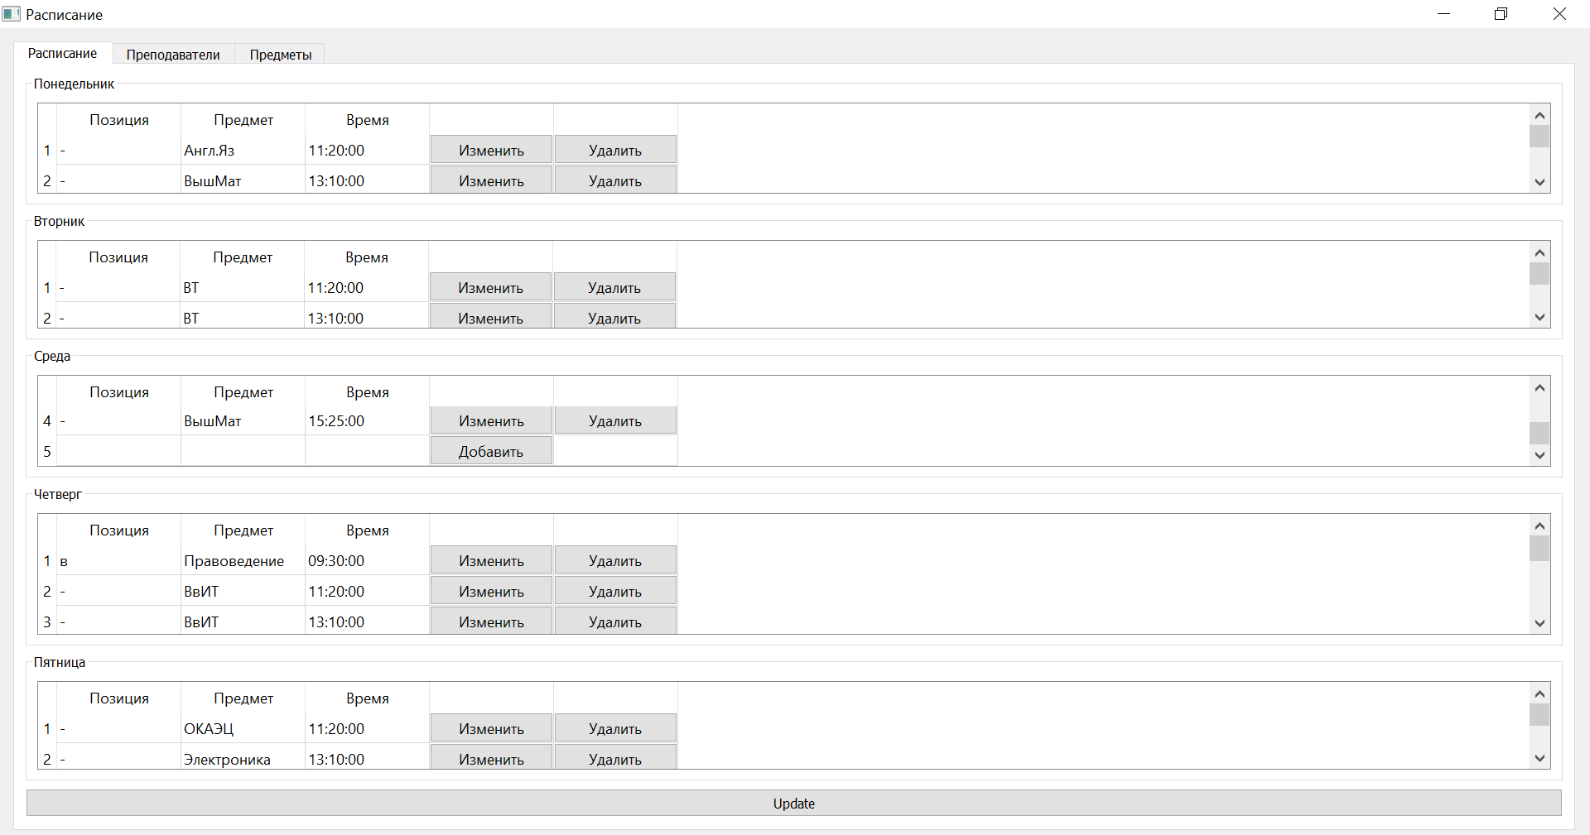

Рисунок 4 – Результат выполнения

# **Вывод**

Мы успешно создали оконное приложение с использованием PyQt5.QtWidget и PostgreSQL с расписанием для своей группы.